

FES DEER MANAGEMENT TEAM BRIEFING
Deer browsing impacts on re-stock sites:
Cowal & Trossachs Forest District 2015

INTRODUCTION

Forest Enterprise Scotland (FES) manages the National Forest Estate (NFE) on behalf of Forestry Commission Scotland (FCS). |  | 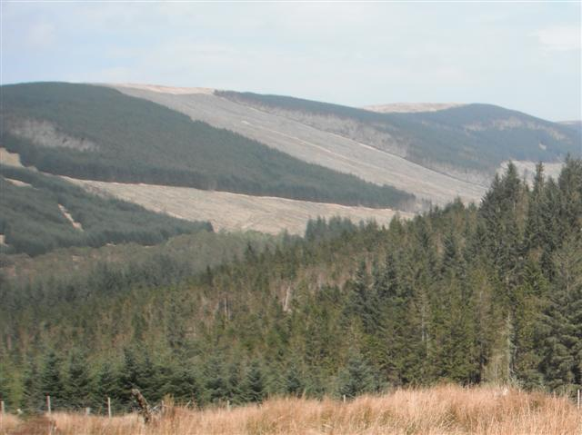
FES management teams are tasked with harvesting mature woodland and re-planting the felled areas within the NFE. The re-planting work normally involves re-stocking the felled areas with new conifer trees, but increasingly also with broadleaves, to provide a future supply of timber.
Re-planting may also involve enrichment of pure commercial conifer stands with broadleaf trees to fulfil local landscape and biodiversity objectives, or may involve the total conversion of felled stands into native broadleaf woodland to meet conservation objectives.
The establishment of new commercial crops or conservation woodland on felled areas is fraught with difficulties. A key difficulty is the extent to which wild deer browse the leading shoots of newly-planted trees.
Browsing can result in growth suppression of all planted trees generally, and long-term growth deformities in commercial stock specifically, leading to additional site establishment costs and reduced harvesting revenues respectively.
FES has a deer management team within each Forest District that is tasked with protecting newly-planted trees from unacceptable levels of browsing impact.
The approach FES generally advocates is to cull deer on a forest-wide basis (i.e. not culling re-stock sites specifically). The aim is to ensure that conditions across each forest as a whole are favourable for the establishment of most tree species in most circumstances. However, fencing of re-planted sites is sometimes advocated for commercial broadleaf crops.
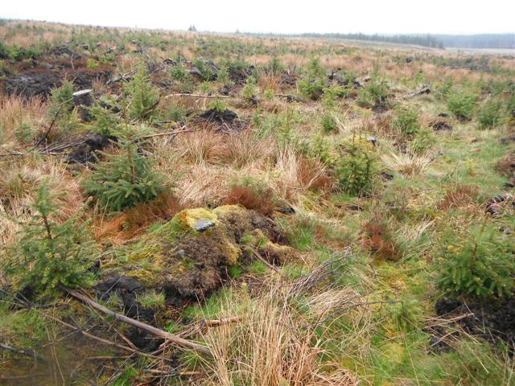 | The size of cull taken in a Forest District to control deer numbers is a balance between the number of forests to protect, the number of re-stocks in each and the relative costs of control; higher unit costs for control arise in areas with lower deer densities.
 | Crucially though, deer are not the only cause of significant impacts on new trees. Sheep cause similar types of browsing impacts to deer. Hare (Brown hare or Mountain hare) and Rabbit can also browse leading shoots. Insect damage, primarily arising from the large pine weevil (Hylobius abietis) which feeds on the bark of new trees, can cause the death of the leading shoot or the entire tree. All such forms of impact can inhibit tree growth rates and some can also cause longer-term problems with timber quality

AIMS OF THIS STUDY
In 2015 FES commissioned Strath Caulaidh Ltd (SCL) to survey all re-stocking sites that had been established in the 2013-14 planting season (PY 2014) in the Cowal & Trossachs FD (see Map 1 in rear of this report & also supplied separately).
The objectives of the 2015 study were to:
1: Quantify levels of deer/sheep browsing impact on the leading shoots of planted conifer crops and broadleaves on target coupes.
2: Compare deer/sheep browsing impact levels to those arising from hare/rabbit (‘other herbivores’) and ‘die-back’.
In order to place the results in context, a summary of the findings from previous studies of this type within the Forest District is presented in this report alongside the results of the most recent survey.

METHODS
The method used for this study is based around the Nearest Neighbour (NN) assessment approach advocated for general use by Forestry Commission (FC) in the 1980’s.
A standard sample size of 20 plots for each coupe is set out on a systematic grid across the whole planted area (see example map). Variations to this approach exist depending on circumstances:
> Very large commercial crop sites (normally> 75ha) are sampled with 40 plots or more to ensure adequate spatial coverage across the site.
> In forests where there are a large number of very small coupes a grid of 100 plots across all planted areas is often used.
> New broadleaf or conifer planting sites, on open range or agricultural fields, are treated differently to re-stock coupes because they are often very extensive and complex. The majority of these sites are normally sampled with 100 plots or more, the aim being to then produce a local map of the results so that managers can see spatial variation in impacts.
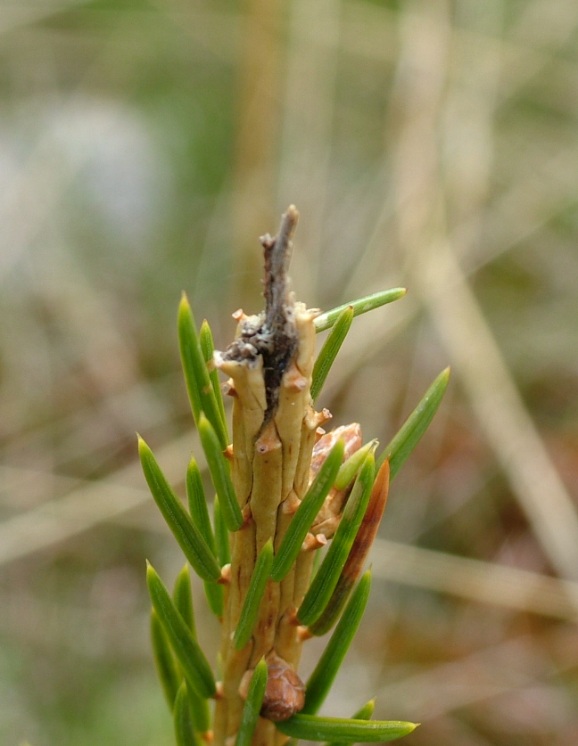  Herbivore damage on commercial crop planting:  browing impact of deer or sheep (top image) and browsing impact of hare/rabbit (lower image) |  |  |  | Each coupe is assessed by SCL between mid-March and late May, when the cumulative impacts of the past season are visible (fresh growth is ignored).
 |  |  |  | GPS is used to locate points. If the GPS point does not fall within a planted area then a radius of 20m is searched and the plot relocated into an area of planting, with distance and direction of relocation noted on the datasheet.
 |  |  |  | At the sampling point, surveyors identify the nearest 5 live planted trees for assessment.
 |  |  |  | If no live trees are found in the search radius this is noted and described, and the survey of that plot then cancelled.
 |  |  |  | Sampled live trees are placed into one of three species groups: Sitka spruce, soft conifer or broadleaf.
The presence/absence of a live apical bud (terminal bud) is noted for each leading shoot on each sampled tree. If the apical bud is found to be missing/damaged, it is classified according to the apparent cause:

> “Tear” - bud appears to have been 'torn' off by deer or sheep (upper image)
> “Snip” - bud appears cleanly 'cut' off by rabbit / hare (or vole) (lower)
> “Die back” - bud present but dead.
 |  |  |  | Weevil impacts are also checked for on each tree stem, and recorded on a presence/absence basis per tree.
 |  |  |  | Deer faecal pellet groups are also counted in the vicinity of each sampling location for research purposes (data not presented herein).
Analysis of the field data is undertaken as follows:
- The % buds lost due to ‘deer/sheep’ browsing, to ‘hare/rabbit’ and to ‘die-back’ are calculated for each coupe. Broadleaf data are analysed separately from Sitka spruce and ‘soft conifers’ (i.e. all other conifer species).
- The weighted average impact levels (commercial conifers & broadleaves), across all coupes combined, are then calculated (multiply ‘% buds lost on each coupe’ by ‘coupe area’ > divide ‘total impacted area’ by ‘total area planted’)
- Data from deer-fenced coupes and from coupes comprising solely natural regeneration (e.g. ATC areas), are omitted from the main results presentation. This ensures the results are comparable nationally across all FD’s (only some FD’s use these techniques, in some areas). These data are presented, on a per coupe basis, in Appendices.

Important Notes: (1) Deer and sheep browsing impacts are difficult to distinguish between unequivocally in field conditions which is why the term ‘deer/sheep’ is employed in the text above. However, in the interests of brevity we use the term ‘deer impacts’ hereon in rather than ‘deer/sheep’.
(2) For a more detailed explanation of the survey methods and analysis approach please see “NN Technical Appendix” (supplied separately).
ANNUAL VARIATIONS IN THE RANGE OF SITES SAMPLED

The ‘background conditions’ in which impact assessments take place can change dramatically from year to year within a FD – the reported changes in impact levels between years in each FD, presented overleaf, are often heavily influenced by these changes in circumstances (i.e. the changes in impact level between years cannot be explained solely by changes from year-to-year in local and regional deer densities in the forests being managed).
 |  | 2010 |  |  |  | 2011 |  |  |  | 2012 |  |  | 2013 |  |  |  | 2014 |  | 2015
No. of unfenced coupes  Number of coupes  assessed (see Appendix 3  for a list of fenced coupes) |  | 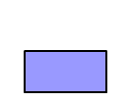 |  |  |  |  |  |  |  |  |  |  |  |  |  |  |  |  | 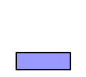
 |  | 16 |  |  |  | 19 |  |  |  | 17 |  |  | 11 |  |  |  | 12 |  | 9
Planted area assessed  Unfenced (ha)*  Fenced (ha)  Pure regen (ha)  * Label = Unfenced area (ha) assessed |  |  |  |  |  |  |  |  |  | 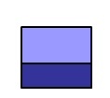 |  |  | 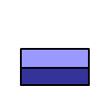 |  |  |  |  |  | 
 |  | 269 |  |  |  | 317 |  |  |  | 162 |  |  | 117 |  |  |  | 293 |  | 156
Geographic zone  % Coupes ‘Trossachs’  % Coupes ‘Cowal’ |  | 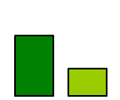 |  |  |  | 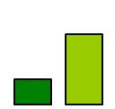 |  |  |  | 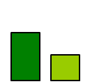 |  |  | 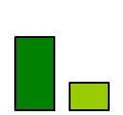 |  |  |  |  |  | 
Coupe sizes assessed  % Coupes 1-10 ha  % Coupes 11-20 ha  % Coupes 21-30 ha  % Coupes 31-40 ha  % Coupes >40 ha |  | 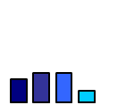 |  |  |  | 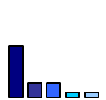 |  |  |  | 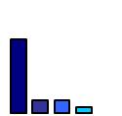 |  |  | 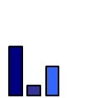 |  |  |  | 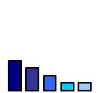 |  | 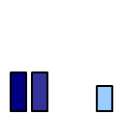
Species composition  % Area planted: Sitka spruce  % Area planted: Soft conifers  % Area planted: Broadleaves |  | 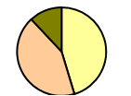 |  |  |  | 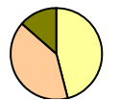 |  |  |  | 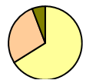 |  |  | 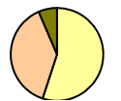 |  |  |  | 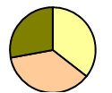 |  | 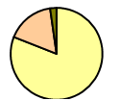
Coupes with sheep signs |  | 6% |  |  |  | 21% |  |  |  | 24% |  |  | 27% |  |  |  | 25% |  | 11%
Broadleaf Coupes  % with tubes  % with fences |  |  |  |  |  | 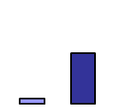 |  |  |  | 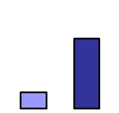 |  |  | 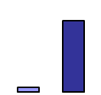 |  |  |  | 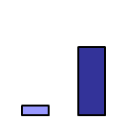 |  | 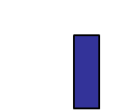
 |  | 0% | 0% |  |  | 5% | 53% |  |  | 17% | 70% |  | 5% |  | 84% |  | 9% | 64% | 0% | 73%
Survey timing  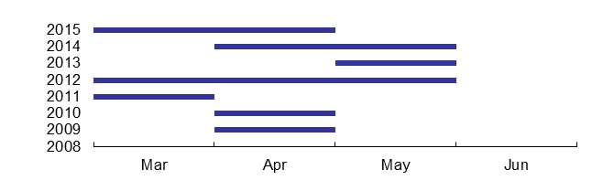 |  |  |  |  |  |  |  | Chart 1: % Planted area fenced in 2015 (red = national averages)  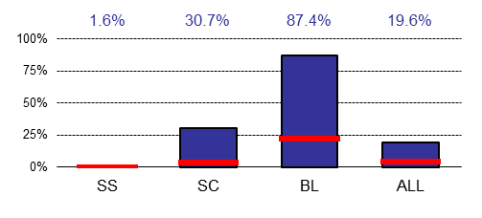
Notable changes in background conditions over time in the Forest District (most important ones in red bold text) are:
- The geographic spread of unfenced coupes sampled in the FD each year has varied markedly.
- Coupe size has varied, with a period from 2011-2013 when small coupes sizes were more common.
- Species composition has varied markedly, in particular the % Sitka spruce sampled.
- Survey timing has varied markedly.
KEY STATISTICS

Chart 1 (on previous page):  - 19.6% of trees sampled in 2015 were deer fenced  - Deer fencing was used on all species groups  - Deer fencing levels: above national average  - Averages nationally (2015): 0% SS, 4% SC, 22% BL  Only unfenced planted tree data presented below…  Chart 2:  - Annual levels of deer impact on commercial conifers have markedly varied over the years: range 17.2 % - 32.9%  - Result for 2015: 16.4% of leading shoots lost  - 3-Yr ‘Rolling Average’ level*: high and stable  - 3-Yr Average vs Target**: well above target  - 3-Yr Av vs National Level***: above average  Chart 3:  - The proportion of commercial sites with impacts > 10% has varied markedly over the period: range 44% - 75%  - Result for 2015: 50% of coupes have impacts >10%  - 3-Yr ‘Rolling Average’ level: stable and high  - 3-Yr Average vs Target *: considerably above target  - 3-Yr Av vs National Level: close to average  Chart 4:  - Annual levels of overall impact (all causes; all Conifers and BLs) have varied markedly: range 20.1% - 43.3% and are at their lowest this year  - Results for 2015: 20.1% of leaders have impacts  - Trend over time: variable but generally high  Chart 5:  - The pattern of deer browsing between tree species groups has varied markedly over the period.  - Some preferences apparent in recent years: broadleaf most heavily browsed.  Note 1: Maps of deer impact levels for conifer and broadleaf across the FD in 2015 are shown in Appendix 1 and also provided as separate attachments.  Note 2: The detailed results for each unfenced coupe surveyed in 2015 are presented in Appendix 2.  Note 3: The detailed results for fenced areas surveyed in 2015 are presented in Appendix 3. Natural regen’ coupes if present are shown in Appendix 4.  Note 4: All coupes planned for assessment in 2015 were sampled (locations shown on map in Appendix 1).  Note 5: Maps of impact levels on coupes intensively sampled (e.g. broadleaf plantings) are supplied separately (no sites assessed this way in 2015). |  |  |  |  |  |  |  |  |  | Chart 2: % Leading shoots lost on commercial conifers  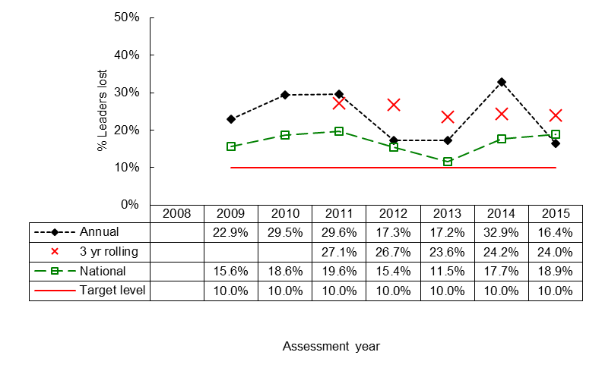
Chart 3: Conifer coupes with impacts >10%

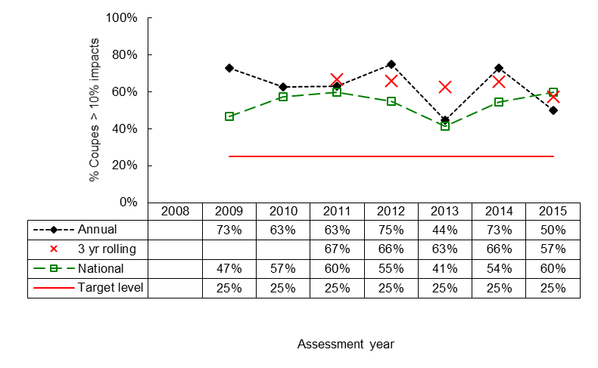
Chart 4: Impacts Overall

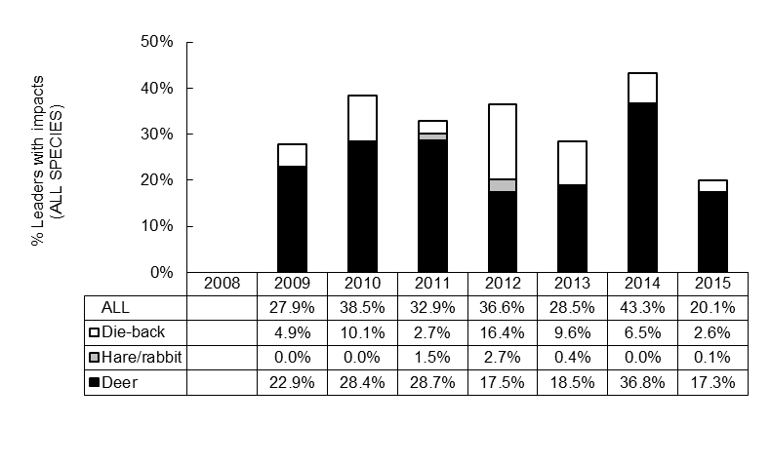
Chart 5: Deer impacts by species | 2010 |  |  |  | 2011 |  |  |  | 2012 |  |  | 2013 |  |  |  | 2014 |  |  | 2015
% Leading shoots recorded as having deer impacts (label = overall %).  Sitka Spruce  Soft Conifer  Broadleaf  All species combined | 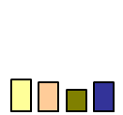 |  |  |  | 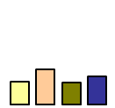 |  |  |  | 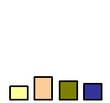 |  |  | 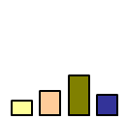 |  |  |  | 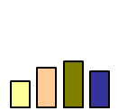 |  |  | 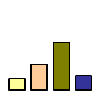
 | 28.4% |  |  |  | 28.7% |  |  |  | 17.5% |  |  | 18.5% |  |  |  | 36.8% |  |  | 17.3%
* 3-Year Rolling Averages: this combines the annual impacts data from a three year period, in an overall weighted average, in order to help ‘smooth out’ the effects of annual variations in Background Conditions ( considered to provide a more useful and reliable trend in impact levels over time).

** Target Levels: these are the provisional deer impact targets that have been agreed for FES managers to use to measure and compare performance.

*** National Average: all the impact data for Scotland are used to produce weighted average statistics at the national scale for benchmarking purposes.

INTERPRETATION
RPRETATION

- SCL has been assessing the level of deer/sheep impacts annually on newly-planted trees in Cowal & Trossachs FD for a period of 7 years.
- At the outset of the study period, recorded impact levels on commercial crops were very high on average compared with target levels and also very high compared with the national average.
- Recorded impact levels in the FD level have at times since been lower, including in 2015.
- However, over this period a number of significant changes in Background Conditions have occurred which complicate the interpretation of trends in the impact data sets presented. The most notable changes, in order of importance, are listed below.
…Firstly, have been many fluctuations in the number of coupes planted, their size and the species of trees planted.
…Secondly, there has been marked variation in the geographic emphasis of sampling with some years weighted towards more coupes in Cowal, and some when Trossachs was more heavily represented.
…Thirdly, sheep have been a consistent feature of around 25% of coupes sampled between 2011-2014. The presence of sheep may lead to elevated levels of impact being recorded on these coupes.
…Fourthly, there have also been wide ranging changes between years in the way in which deer fencing is employed and, in tandem with the other changes described above, complex variation between years is apparent.
…Lastly, has also been a degree of variation in the timing of the surveys. This can have implications because, typically, later surveys record higher impact levels because deer browsing impacts accumulate over the winter into spring period.
- It is apparent from the wide ranging Background Conditions that we would expect average impact levels on unfenced sites in Cowal & Trossachs FD to vary simply as a result of these changes. However, it is unlikely that all of this variability is related to Background Conditions. That is, at least some of the variation is likely to relate to local changes in deer density (i.e. deer populations are likely to be rising in some areas, even if they are falling in others, given the generally high level of average impacts apparent).
- Given the information we have to hand we conclude that conditions for fenceless crop establishment in Cowal & Trossachs FD are “frequently unfavourable - stable but locally favourable - possibly improving”. Our basis for proposing this outlook is that there is evidence to suggest that a significant proportion of sites are still experiencing High (Orange) or Very High (red) impact levels (see Appendix 1), and we know from previous studies in this area that this has also been the case historically across much of the FD when crops are established without fences.

RECOMMENDATIONS

We make the following recommendations following the 2015 survey:
- This report: the results presented in this report should be reviewed by the relevant FD staff, and then SCL should be contacted so that all parties can discuss the findings in detail to ensure that data are interpreted appropriately.
- The district cull: it appears that deer densities in many places within the FD remain above the level ideally required to facilitate fenceless establishment of high quality crops; we conclude that culling intensities will need to be increased in these areas if conditions are to be improved. An analysis of historic and present culling intensities in each DMU, allied to historic impact levels and previous Population Assessment surveys, is recommended to help identify candidate areas.
- Future reports: the 2016 survey report might usefully include an analysis that ‘weights’ each year of results by the planted area (ha) of each geographic zone described in this report, to try and account for any biases arising from changes in the geographic emphasis of sampling between years. FES should consider this option and discuss with SCL.
- Future reports: an analysis of the historic changes in the pattern of culling in the FD (by DMU or zone) would be very useful to include in future reports of this type, because it would help demonstrate to Forest Management staff and to Environment staff the degree of effort, and changes in effort, applied by Deer Management staff in trying to reduce impacts to an acceptable level. FES should consider this option and discuss with SCL.
NB It must be remembered that, no matter what the levels of impact recorded in the FD annually, the deer culling process is highly demanding and DM personnel work long anti-social hours in often very difficult conditions. The data presented herein should of course be used by the whole FES management team and staff to introduce any change necessary, but managers should always take into account the physical difficulty of the culling work needed to deliver change.


Strath Caulaidh Ltd
1 Strathallan Bank
Ardargie, by Forgandenny,
Perth
PH2 9FE
Tel: +44 (0)1738 815949
info@strathcaulaidh.com
www.strathcaulaidh.com

APPENDIX 1 – IMPACT LEVELS ON CONIFER AND BROADLEAF CROPS

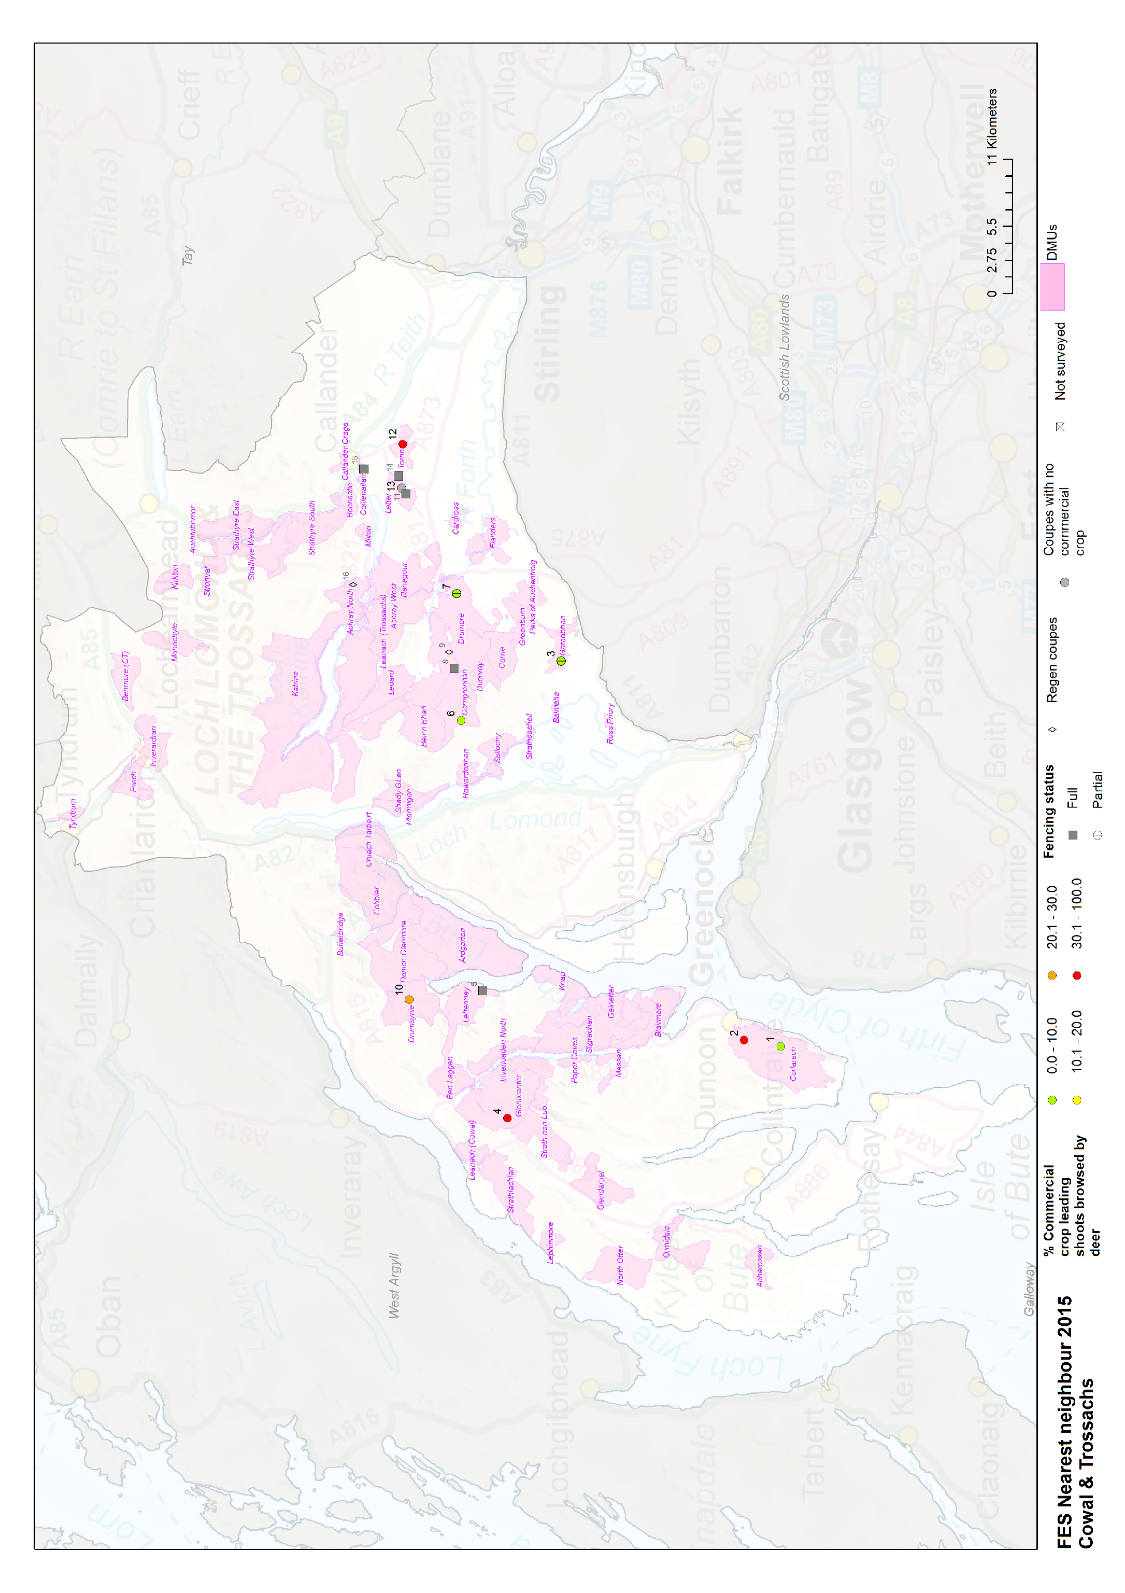

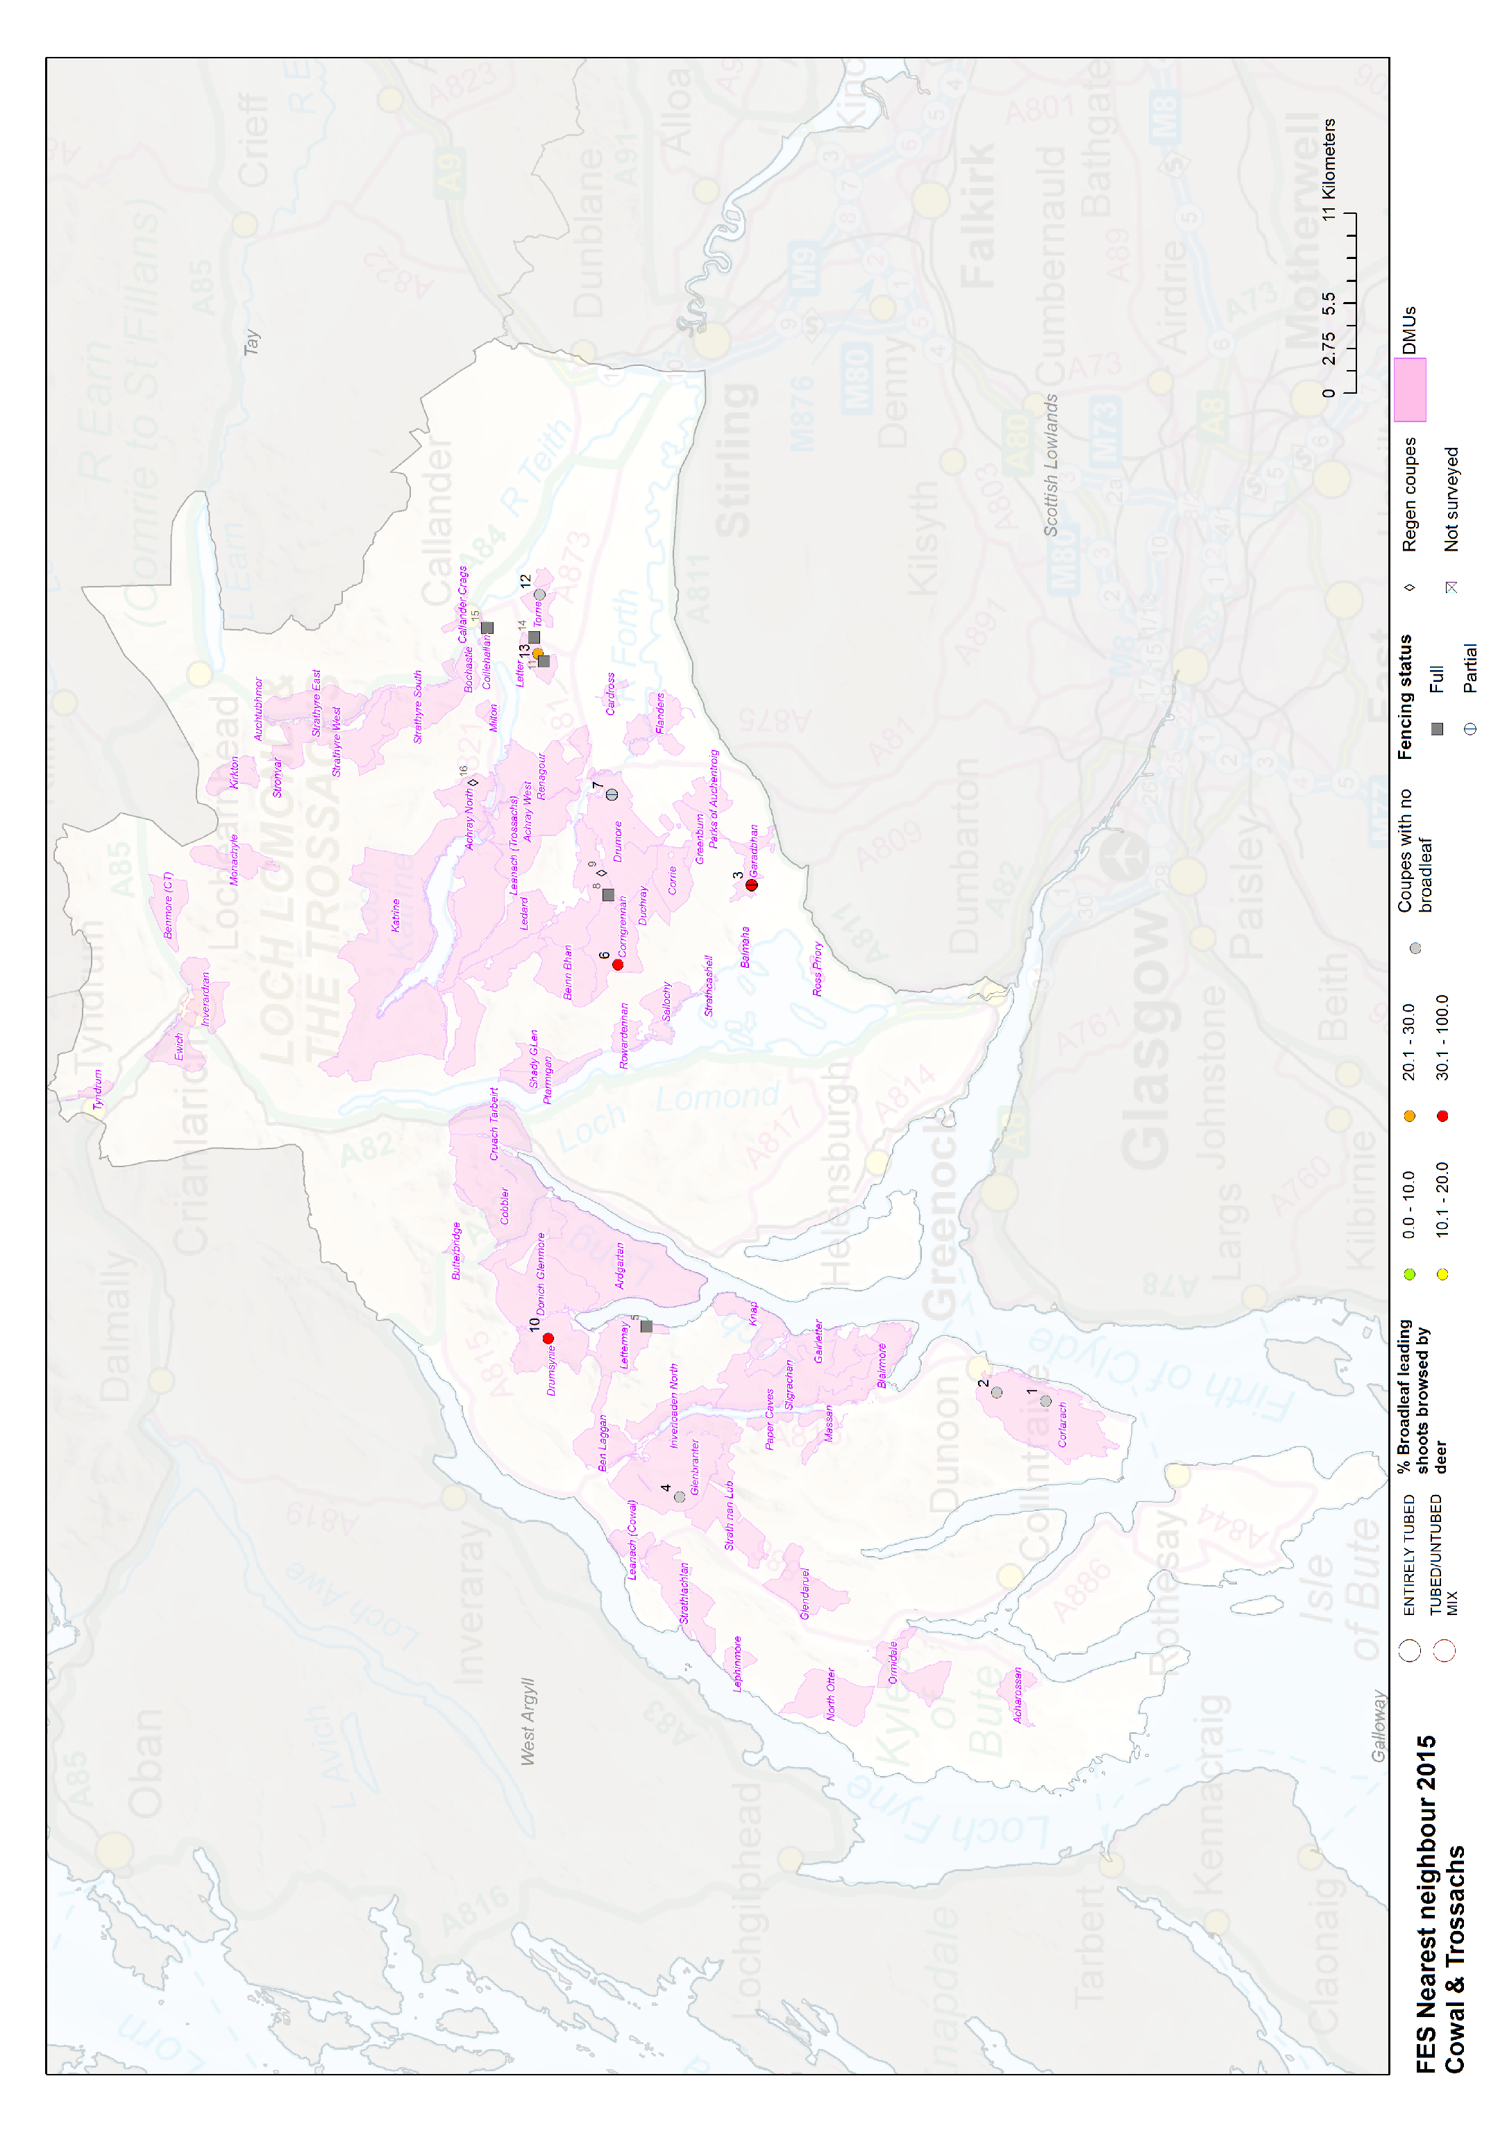

APPENDIX 2 – COUPE RESULTS (UNFENCED COMPONENTS)

Deer impacts key: Very High (>30%); High (21-30%); Moderate (11-20%); Low (<10%);
SCL coupe code | FES coupe codes | DMU extent name | AREA (HA) |  |  |  | DEER IMPACTS BY SPECIES |  |  |  | IMPACTS BY TYPE |  |  | Coupe part fenced? | BL tubing?
SCL coupe code | FES coupe codes | DMU extent name | SS | SC | BL | All | % SS - DEER | % SOFT - DEER | % BL - DEER | % SS/SOFT - DEER | % DAMAGED BY DEER | % DAMAGED BY HERB | % DAMAGED BY DB | Coupe part fenced? | BL tubing?
CT_2015_12 | 84009 | Torrie | 1.8 | 3.8 |  | 5.6 | 70% | 79% |  | 76% | 76% | 3% | 2% | N | NA
CT_2015_02 | 11012 | Corlarach | 13.6 | 4.1 |  | 17.8 | 42% | 37% |  | 41% | 41% | 0% | 2% | N | NA
CT_2015_04 | 07087 | Glenbranter | 11.8 | 2.4 |  | 14.2 | 20% | 80% |  | 30% | 30% | 0% | 1% | N | NA
CT_2015_10 | 04060 | Drumsynie | 8.1 | 2.3 | 0.3 | 10.7 | 16% | 63% | 93% | 26% | 28% | 0% | 0% | N | N
CT_2015_01 | 11041 | Corlarach | 45.6 | 2.1 |  | 47.6 | 10% | 0% |  | 9% | 9% | 0% | 2% | N | NA
CT_2015_06 | 36013 | Corrigrennan | 41.2 |  | 1.2 | 42.4 | 4% |  | 86% | 4% | 7% | 0% | 5% | N | N
CT_2015_03 | 61000,61004,61009* | Garadbhan | 0.6 | 9.1 | 0.8 | 10.5 | 7% | 2% | 46% | 3% | 6% | 0% | 3% | Y | N
CT_2015_07 | 34001 | Drumore | 3.5 | 2.4 |  | 5.9 | 0% | 0% |  | 0% | 0% | 0% | 0% | Y | N
CT_2015_13 | 88004 | Letter |  |  | 1.2 | 1.2 |  |  | 29% |  | 29% | 3% | 11% | N | N

N.B
N.B Coupes with sheep signs present marked in red text.

APPENDIX 3 – COUPE RESULTS (FENCED COMPONENTS)

Deer impacts key: Very High (>30%); High (21-30%); Moderate (11-20%); Low (<10%);
SCL coupe code | FES coupe codes | DMU extent name | AREA (HA) |  |  |  | DEER IMPACTS BY SPECIES |  |  |  | IMPACTS BY TYPE |  |  | Coupe part fenced? | BL tubing?
SCL coupe code | FES coupe codes | DMU extent name | SS | SC | BL | All | % SS - DEER | % SOFT - DEER | % BL - DEER | % SS/SOFT - DEER | % DAMAGED BY DEER | % DAMAGED BY HERB | % DAMAGED BY DB | Coupe part fenced? | BL tubing?
CT_2015_07 | 34001 | Drumore |  | 5.9 | 1.9 | 7.8 |  | 2% | 0% | 2% | 1% | 0% | 2% | PF | N
CT_2015_15 | 85003,85004,85017 | Coillehallan |  | 2.0 | 3.1 | 5.1 |  | 1% | 0% | 1% | 1% | 0% | 1% | F | N
CT_2015_03 | 61000,61004,61009* | Garadbhan |  |  | 1.8 | 1.8 |  |  | 17% |  | 17% | 3% | 0% | PF | N
CT_2015_05 | 04107,04143 | Lettermay |  |  | 10.1 | 10.1 |  |  | 5% |  | 5% | 1% | 7% | F | N
CT_2015_08 | 30016 | Renagour |  | 2.1 | 3.1 | 5.2 |  | 0% | 11% | 0% | 7% | 0% | 7% | F | N
CT_2015_11 | 88004 | Letter |  |  | 4.0 | 4.0 |  |  | 16% |  | 16% | 2% | 5% | F | N
CT_2015_14 | 88032 | Letter | 2.0 | 1.5 | 0.5 | 4.1 | 0% | 0% | 0% | 0% | 0% | 0% | 18% | F | N

N.B Coupes with sheep signs present marked in red text.

APPENDIX 4 – COUPE RESULTS (NATURAL REGEN’ COMPONENTS)

Deer impacts key: Very High (>30%); High (21-30%); Moderate (11-20%); Low (<10%);
SCL coupe code | FES coupe codes | DMU extent name | AREA (HA) |  |  |  | DEER IMPACTS BY SPECIES |  |  |  | IMPACTS BY TYPE |  |  | Coupe part fenced? | BL tubing?
SCL coupe code | FES coupe codes | DMU extent name | SS | SC | BL | All | % SS - DEER | % SOFT - DEER | % BL - DEER | % SS/SOFT - DEER | % DAMAGED BY DEER | % DAMAGED BY HERB | % DAMAGED BY DB | Coupe part fenced? | BL tubing?
CT_2015_16 | 22005 | Achray North |  | 0.6 |  | 0.6 |  | 61% |  | 61% | 61% | 0% | 0% | N | NA
CT_2015_09 | 30039 | Renagour |  |  | 0.1 | 0.1 |  |  | 76% |  | 76% | 0% | 4% | N | Y

N.B Coupes with sheep signs present marked in red text.

